Jesus with us: “you’re worth it!”

Last friday I was playing tennis with a group of Dutch ladies—two of them have been my friends for almost 20 years. That’s a long time! Two other women are newer friends. After a rousing game of tennis, we began to chat over coffee. One of my newer tennis friends began to tell us about a recent trip she took with some friends to Marrakech. she said it was like going back a hundred years in time,. Such a culture shock. And, she said proudly, “I now know my value!” “Oh?” (we all wanted to know!). “yes”, she said with a laugh. She had been shopping with the group of Dutch girlfriends. They were negotiating for something in a shop—and it took quite some time. The shopkeeper was mightily impressed by her, apparently. She says it must have been her negotiating ability, or her size (she’s a Dutch version of Serena Williams, a strong and big hitter) and her sassiness. She told us, “I am worth a camel and a Riad (kind of a villa)”.

What are you and I worth? It’s a good question!
Worth is strongly related to who and what you are, -- related to your identity-- and related to who it is who is doing the valuing.

Identity, the experts say, falls into two broad categories: the first is something called ‘earned identity’, which comes out of what you do or have, or what people say about you. The second is called ‘given’ identity, which is based on characteristics you can’t do very much about, like your gender, your family, your race. Everyone has both kinds of identity, but experts say that people tend to be most attached to, they pay the most attention to, the identity that (they feel) brings them the most benefit.

Tallness, for example.
Yesterday at the AH, I couldn’t reach something and I asked a man passing by me, a very tall man, if he wouldn’t mind getting two jars off the top shelf for me. He and his wife laughed. When I asked him if he got requests like that all the time he just smiled and said he practically ‘works there’. I didn’t get the impression that he thought his height was very important. For some people, like basketball players or volleyball players, it’s a very important part of their identity because it’s part of their job.

What are some of the identities that you are most attached to? It may not be easy to identify them, but the identities you value most of all are the ones that tend to show up in some of your choices and in the way you see people and life.

Why does this matter? Imagine two scenarios. Imagine first that, in living out your most important identity, you’re disappointed. This will often show up in feelings of disqualification… “I can’t…” Eventually you might feel, “I’m on the outside, I don’t belong”. Other people feel like competitors, and you’re frustrated.

That’s one scenario. Imagine now that you feel fulfilled in your identity; well, then, you feel like you belong, you feel safe and whole. Rather than feeling disqualified, you feel empowered and you experience benefits like connection with other people, and purpose in your life. Quite a difference. Do you get these concepts?

Because these ideas are an important part of the story we are reading today.

This story in the gospel of John describes how Jesus gives one man back his true identity. A man goes from disqualified to empowered.

So, in john’s good news story about Jesus, john says he has made a careful choice about what to tell us… can you imagine John sitting down praying and asking God to help him choose which things to share? Which things-- among all the things John experienced in the years he spent with Jesus? What could he say to help us believe and experience life in Jesus? What to include, what are less important details?

Keeping that thought in mind, we are going to look now at a meeting Jesus had with someone, found in John 5. Think of it as a kind of dot-to-dot picture today. Did you ever do those when you were little? If you miss one dot, then the picture doesn't come out as well; it can be distorted. Let’s try to get as many dots as possible this morning

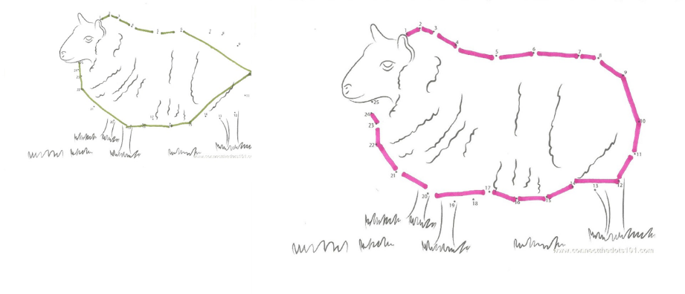Text John 5: 1-9
1Some time later, Jesus went up to Jerusalem for one of the Jewish festivals. 2Now there is in Jerusalem near the Sheep Gate a pool, which in Aramaic is called Bethesda and which is surrounded by five covered colonnades. 3Here a great number of disabled people used to lie—the blind, the lame, the paralyzed. [4] (—and they waited for the moving of the waters. From time to time an angel of the Lord would come down and stir up the waters. The first one into the pool after each such disturbance would be cured of whatever disease they had.) 5One who was there had been an invalid for thirty-eight years. 6When Jesus saw him lying there and perceived that he had been in this condition for a long time, he asked him, “Do you want to get well?” 7“Sir,” the invalid replied, “I have no one to help me into the pool when the water is stirred. While I am trying to get in, someone else goes down ahead of me.” 8Then Jesus said to him, “Get up! Pick up your mat and walk.” 9At once the man was cured; he picked up his mat and walked. The day on which this took place was a Sabbath

Let's follow the dots that John leaves us. Well, verse one starts with the word ‘Afterward, sometime later’, ‘after these things’. What things? What happened before this, which makes this somehow a continuation of another part of John’s story? That makes us look back into john 4. There we see that the entire chapter shows Jesus revealing himself to people. People are believing his message and getting life. What kind of people? they were outsiders, like the Samaritan woman and the Roman official. What do I mean by outsiders? I mean they are on the outside of Israel. Outside, here, means disqualified. Most of the chosen people did not expect anyone on the outside to be able to have a part in God’s plan, or to enjoy any relationship with God. Remember what Hans said last week in his sermon? That Jesus came, through the Jewish people, to bless all nations? Some people in Israel had forgotten this.
To Jesus, though, no one is an outsider, no one is disqualified, the flock includes everyone—

We do not hear from John which festival is going on in Jerusalem. Commentaries do not agree with each other. So john must not have felt that that piece of information was important here. No dot. What details does john report? Also, are there things in his report that we need to think more carefully about – things that might have been obvious to john’s first century readers, but not to us? Jesus goes into the city and walks to a ritual bath pool located right outside the Sheeps gate.

It’s worth saying a few words about this place, since John mentions it. For him, it’s a dot. Let’s try to figure out WHY/Cities grow over time, and Jerusalem has also many layers of city walls, each with many gates. The sheeps gate is in the oldest wall, and it is where the lambs were herded toward the temple for sacrifice. The temple was just on the other side of this gate.John’s readers would know that during this festival (whichever festival there was) there would be a constant stream of lambs brought into the city, to be used for sacrifice.

So perhaps this gives us an idea of Jesus’ mindset. Picture Jesus, standing very likely near this gate in the ancient walls of Jerusalem, so close by. Jesus would see this gate, would see the lambs herded in. It’s just speculation, but what might have been going through his mind? Jesus, the Lamb of God, our good shepherd… caring about all the people who have lost their way…

We also hear from John that the name of the pool structure is Bethsaida, ‘house of mercy’. John gives us a detailed description of the building: it’s a five-sided structure. Here’s a picture of a model someone made; it’s kind of unusual. Can you see the gate, and behind it the walkway to the gate?

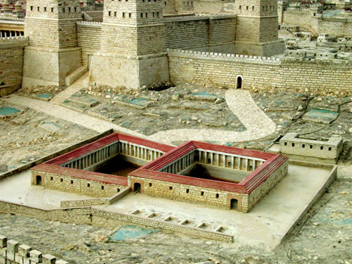

What other details do we hear from john? We hear that there are covered walkways all around the pool, providing shade. John says that crowds of infirm people were gathered along these walkways, waiting for a miracle. According to some original texts of the bible, they believed that miracle would come from an angel of God, who would appear now and then and stir the water. The first one to get into the water would be first one out-- healed. There were still crowds of people waiting.

First-century people would know that this place full of sick people is a place of outsiders! Yes, they have the identity of chosen people of God, but they have become disqualified by their infirmities. Who says they are disqualified? It’s the culture, devaluing and then discarding people according to outside things—“what you do, what you have, what others say about you”. I wish we could say that culture has changed in 2000 years….

What happens now? Jesus has entered the crowded and unhappy pool structure—it’s really quite large-- and goes up to one man lying there. John says that Jesus saw him and ‘perceived’ that the man had been there for a long time. The word used here is perceived. John doesn’t tell us right then how Jesus knew this. A good guess, based on verse 19, later in this chapter, is that the Father told Jesus the plan; the father showed Jesus what he wanted to do. Why do I say that? In verse 19, Jesus said, “the Son does only what he sees the father doing. Whatever the father does, the son also does. For the father loves the son and shows him everything he is doing.”

Jesus was connecting the dots of being a dearly loved son. He was showing us that we human beings could do this too, as beloved children of the father..
For example: he showed us what it looked like
to live life knowing the Father loves us,
to rely on the father by praying, what it looked like
to listen to the father. What it looked like
to value people who are beloved of the father. What it looked like
to wait for the Father’s timing.

What do you think? Do you think this was easy for him? Jesus is fully God, but he also was fully man, and he had, I think, to work at connecting with the Father, to work at trusting, listening. It’s this vulnerability and love of Jesus that fills me with joy in the word Emmanuel, which we hear so much near Christmas. I love the word Emmanuel! God with us, among us.

As our big brother, Jesus continually shows us, what it looks like to be in step with God. And, notice how he does this also respecting our freedom to choose for ourselves! He the good shepherd, and we are the sheep who recognize his voice, and want to come.

What does john tell us about the conversation? John doesn’t give us a lot of dialog. Jesus asks a question, the man answers him, and Jesus tells him to do something. What he says to the man gives him power to be healed. First, Jesus, knowing how long the man has been there, asks one direct question, ‘do you want to be made whole?’. Why would Jesus ask such a question? Wouldn’t you think that would be obvious? I’m sure that Jesus asked the question on purpose. Sitting there among the crowds, through the long years, the man had perhaps slowly given up hope. He had put aside his identity as son of Abraham, and had gradually taken on identity of victim, sick one, outsider. Jesus cares about that. Yes, he understands how hurt we are—he understands how crushed we can feel when life falls far short of hopes and dreams. Jesus has seen the lambs being led through the sheep’s gate. He knows how people long to be healed of brokenness, and how frustrated they are when they realize that that sacrifice – or whatever they are doing-- will never be enough to change things. So Jesus goes deep and asks the question, I think, to allow the man to hear the shepherd’s voice and also to express himself. And Jesus listens. There’s a certain power in the right kind of question, one that lets another person be free to reveal him or herself.

The man says, ‘Sir, I am stuck here with no one to help me get into the water when the angel stirs it up. I can never get well, because I am helpless to get into the water before the others, who always get there first.’ It is kind of a roundabout answer, basically the man seems to be saying “yes, I want to get better, but my best plan to get there is not working”. Can you hear the frustration in this? Did you also notice the word ‘Sir’? Honorable one, Lord. Can you see the man looking up at Jesus to say this? The sheep know who the shepherd is.

Later in verse 13 we hear that the man didn’t know very much about Jesus at all. He didn’t know that Jesus was the one who had been doing miracles, for example. The man couldn’t even tell the authorities who it was who had healed him. The man is also saying that he competes with the other people crowding around the pool. He is utterly alone. So, the man is looking up at Jesus, as one who draws him out of isolation. As one who might help him reach his plan. What does Jesus say to this man’s sad story about the failed plan? He says something like, ‘I’ve just downloaded a much better plan from the Father. Can you trust me? stand up, now; pick up your mat and walk’.

Did you ever have a plan – call it ‘plan A’-- that didn’t work? So frustrating, and you had it all worked out and -- you prayed so hard about it! Then later, you notice that things happen and another plan unfolds—call it ‘plan B’—and it’s much better? Has anyone else experienced that?

John says, that at Jesus’ word something happened. ‘at once he was healed. He picked up his mat and walked’.
Imagine that this man hears the shepherd’s word, and agrees. Eyes on Jesus. How does he show he agrees? He participates. Something clicks inside and He stands up; I can do that!
What about picking up the mat? Jesus tells him to put this infirmity—this false identity-- behind him. It's kind of a burning bridges thing. There’s no place to go back to now. No more reserved spot. Look behind, and the crowd has taken the spot. This man is meant to walk, to live, to look ahead. He’s not meant to lay there in failure; of course, his plan to heal himself could never succeed. Our own efforts are equally doomed! Jesus is gentle but oh so firm. Get up now, I am the one who saves and restores. Don’t go back to your old plan.

Today he’s asking us, Do you hear my voice? Do have a mat to take up?

I want to hear his voice!

Jesus is the one to help us. He’s the only one. The only one who perfectly knows his true identity as beloved Son of the Father. He’s the only one who lived it out – everyday—through all of our circumstances-- as a human being. That is how he brought us to the father! He lived his life among us, he felt and experienced the Father’s love, he constantly was seeking the Father in prayer, always waiting to hear from the Father before doing anything. This Jesus, who knows us so well, who knows the Father so well: He is the one who can help us get back our own true identity as beloved sons and daughters of the Father. He speaks to us now, and he says we will recognize his voice.

The world is constantly pressing us into the mold of competition and find-it-yourself life. But we have the Holy Spirit. The Holy Spirit is here to help us-- to be in us and through us.

Paul said,
no matter what my circumstances are, ‘I can do all things through Christ, who gives me strength.’ Phil. 4:13

I told you earlier about my tennis friend who was “valued greatly”—camel and villa. I still laugh as I remember how we all sat there with our coffees, trying to figure out how much her husband would have to counteroffer, relatively speaking, if she had been tempted… sportscar and a mansion in Wassenaar? I realize now that as we were chatting, I began to look at my friend differently. I was thinking to myself, how had this man in the shop seen her that he would value her so highly? Yes, I could agree, she is lovely and funny. Her husband probably agrees, and though he couldn't offer her a camel, I think she will stay in Holland, after all! But it did stretch me in that moment to begin to understand how much she was valued. I realized, then, that I didn’t really value her enough: I could still could value her much more! And I felt the Lord wanted me to recall that His own valuation of her, of us all, is so high and beautiful…

Is it possible that today we can agree -- even more fully -- how wonderful Jesus is and that we can affirm – even more-- how God loves each of us as beloved children? Jesus lived out of his identity: “my Dad loves me. My Dad loves you too!”

Questions huisgroepen
Spend some time together or individually thinking about what it means that Jesus came to be one of us—fully human and yet fully God. What draws you the most to Jesus? Speak it out in worship

Some people might like to react to this part of the sermon: Did you ever have a plan – call it ‘plan A’-- that didn’t work? So frustrating, and you had it all worked out and -- you prayed so hard about it! Then later, you notice that another plan has unfolded—call it ‘plan B’—and it’s much better? Has anyone else experienced that? What does this do for your faith?

Jesus said in John 10 that his sheep recognize his voice. In the middle of all the input that you get each day, how do you personally recognize the shepherd’s voice? Can you describe a particular time? Can you imagine that remembering this situation (where you heard his voice in the midst of circumstances or life) will build up your faith during difficult times? You may like to read the “I am” in John 10.

